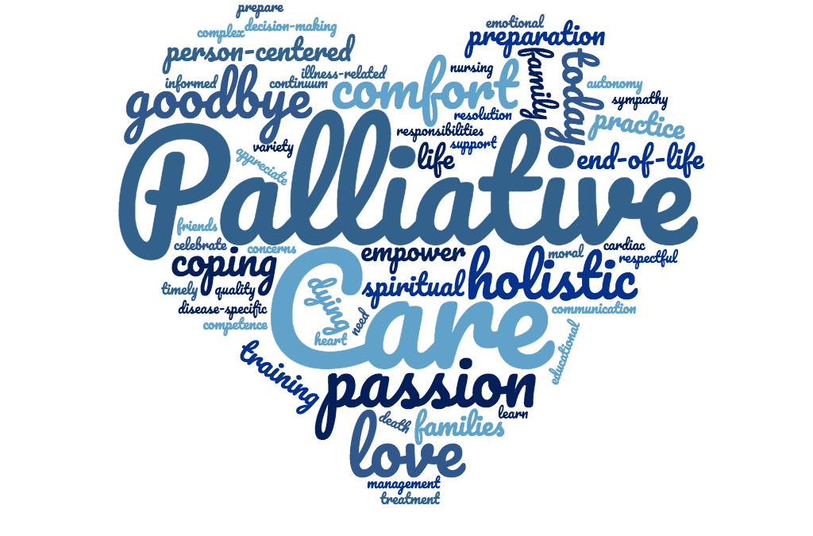 |  |  |  | Claresholm Home Care

Palliative Care - Home Care
Home care provides in-home care, support, and comfort to people coming to the end of their lives and their families with a focus on managing symptoms, and providing emotional and psychological support.
Services Home Care provides include :
- Assessment and Management by Case Managers related to the patients physical symptoms (pain, depression, anxiety, incontinence)
- Support for patients and family members to help cope with emotional, psychological and spiritual concerns with end of life
- Coordinate care for in Home support service - Assistance with personal care, caregiver respite, and volunteer support
- Assess and coordinate equipment needs to support patients to remain at home. Work with Occupational Therapist.
- Facilitate and Coordinate transitions to alternate care settings – Hospice or Long Term Care.
- Facilitate discussions around end of life decision making. Social Worker works closely with Case Manager in this regard.
- Coordinating care with Family Physician and Rural Palliative Care Team
- Coordinate and assisting with Palliative In-Home Funding.
- Patient and Family Teaching as needs arise.

Social Work
Social workers provide a broad range of services related to social and family support services by assisting clients from various backgrounds solve issues with human relationships and enhance their social well-being. Some of the services social workers perform for clients are interventions, emotional support, advocacy, referrals, counseling, discharge and after-care plans. They are part of a multi-disciplinary team whose focus is to provide quality patient care and family services. As well, social workers work with their clients’ families to ensure certain needs such as food, housing, and transportation are met.

- Psychosocial assessments to determine needs of patients and family care givers.
- Facilitating Advance Care planning (i.e. Goals of Care, Personal Directive, Wills, and Enduring Power of Attorney).
- Advocacy on behalf of the patient and family
- Financial Assistance/ Resource Exploration
- Grief Support/Care Giver Support
- Exploration of Accommodation/ Housing Needs.

Occupational Therapist
Occupational therapy is a health profession which enables people to participate in everyday life activities to the best of their ability despite their condition, illness progression, activity limitations or participation restrictions. In palliative care this premise does not change, as occupational therapists are skilled in enabling people to adapt to their changing ability levels, and helping people to continue living.

- Teach patients how to use medical or adaptive equipment to overcome barriers and make life easier (for example: Lifts, power wheelchairs, kitchen utensils)
- Develop a patient’s skills to cope with anxiety, stress, decreased energy or the normal aging process
- Develop a patient’s skills to handle problems with memory, attention, organization or perception

- Problem solve with a patient to discover and teach new ways to perform household chores, hobbies or work activities

5221 2 Street West
Claresholm Alberta
 |  | 403-625-4061
After Hours Number
1-855-955-6665

